Урок 16 beginner

В жизни мы очень часто сравниваем. Себя с другими людьми, разные действия и предметы. Их размер, цвет, вес и другие характеристики. При сравнении в русском  языке мы используем степени сравнения прилагательных – красивый, красивее или более красивый, самый красивый или наикрасивейший. Как сравнивать в английском языке?

**Посмотрите видео**

Степени сравнения.mp4

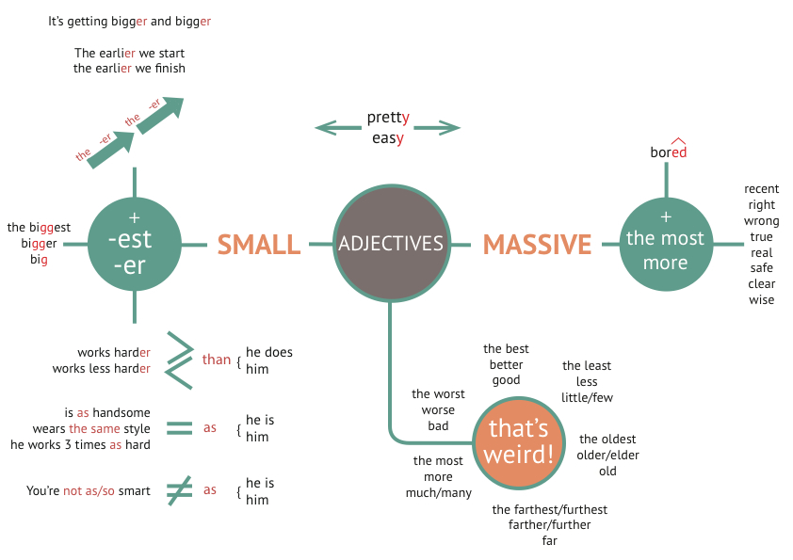

Также на сегодняшний день существует система двойных стандартов в отношении двухсложных слов. Они могут формировать степени сравнения по двум типам.

Pretty – prettier/more pretty – the prettiest/the most pretty

Clever – cleverer/more clever – the cleverest/the most clever

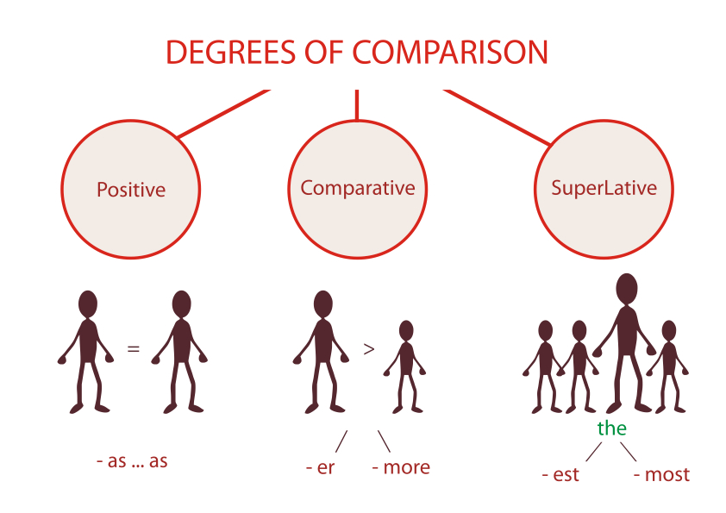

**Образуйте степени сравнения от следующих глаголов.**

Прилагательные

1. hot
2. long
3. short
4. interesting
5. clever
6. silly
7. beautiful
8. great
9. red
10. black
11. fashionable
12. white
13. thin
14. thick
15. expensive
16. fat
17. nice
18. warm
19. modern
20. cold
21. merry
22. pretty
23. comfortable
24. small
25. tall
26. emotional
27. high
28. weak
29. strong
30. attractive
31. heavy
32. light
33. green
34. boring
35. dry
36. clean
37. difficult
38. cool
39. useful
40. dirty
41. wide
42. deep
43. serious
44. brave

Проверьте себя

1. hot – hotter – the hottest
2. long – longer – the longest
3. short – shorter – the shortest
4. interesting – more interesting – the most interesting
5. clever  – cleverer – the cleverest (more clever the most clever – двойной стандарт)
6. silly – sillier – the silliest (more silly – the most silly)
7. beautiful – more beautiful – the most beautiful
8. great – greater – the greatest
9. red – redder – the reddest
10. black – blacker – the blackest
11. fashionable – more fashionable – the most fashionable
12. white – whiter – the whitest
13. thin – thinner – the thinnest
14. thick – thicker – the thickest
15. expensive – more expensive – the most expensive
16. fat – fatter – the fattest
17. nice – nicer – the nicest
18. warm – warmer – the warmest
19. modern – more modern – the most modern
20. cold – colder – the coldest
21. merry – merrier – the merriest (more merry – the most merry)
22. pretty – prettier – the prettiest (more pretty – the most pretty)
23. comfortable – more comfortable – the most comfortable
24. small – smaller – the smallest
25. tall – taller – the tallest
26. emotional – more emotional – the most emotional
27. high – higher – the highest
28. weak – weaker – the weakest
29. strong – stronger – the strongest
30. attractive – more attractive – the most attractive
31. heavy – heavier – the heaviest (more heavy – the most heavy)
32. light – lighter – the lightest
33. green – greener – the greenest
34. boring – more boring – the most boring
35. dry – drier – the driest
36. clean – cleaner – the cleanest
37. difficult – more difficult – the most difficult
38. cool – cooler – the coolest
39. useful – more useful – the most useful
40. dirty – dirtier – the dirtiest (more dirty – the most dirty)
41. wide – wider – the widest
42. deep – deeper – the deepest
43. serious – more serious – the most serious
44. brave – braver – the bravest.

**Посмотрите видео на внешнем ресурсе:**

* <http://www.engvid.com/superlative-adjectives/>
* <http://www.engvid.com/comparing-funner-faster-syllables/>
* <http://www.engvid.com/comparative-superlative-adjectives-exceptions/>
* <http://www.engvid.com/english-grammar-superlative-adjectives/>
* <http://www.engvid.com/english-grammar-comparative-adjectives/>

**Употребите прилагательные в превосходной степени.**

Упражнение

1. Who is the (rich) person in the USA?
2. What is the (long) river in Russia?
3. Where is the (old) theatre in Europe?
4. What is the (beautiful) building in Moscow?
5. Who is the (young) in your class?
6. Who is the (popular) actor in Britain?
7. Who is the (intelligent) student in your group?
8. Where is the (hot) climate in the world?

Проверь себя

1. richest
2. longest
3. oldest
4. most beautiful
5. youngest
6. most popular
7. most intelligent
8. hottest

**Выполните упражнение**, используя сравнительную и превосходную степень выделенного прилагательного,  
*по модели:**A cat is fast, a tiger is faster, but a cheetah is the fastest.*

Упражнение

1. A car is heavy, a truck (грузовик) is …, but a train is the … .
2. A park bench is comfortable, a restaurant chair is …, but a sofa is the … .
3. A horse is big, a bear is …, but an elephant is the … .
4. A lake is deep, a sea is …, but an ocean is the … .
5. A soap opera is interesting, an adventure is …, but a detective story is the … .
6. English is difficult, Italian is …, but Japanese is the … .

Проверь себя

1. A car is heavy, a truck (грузовик) is heavier, but a train is the heaviest.
2. A park bench is comfortable, a restaurant chair is more comfortable, but a sofa is the most comfortable.
3. A horse is big, a bear is bigger, but an elephant is the biggest.
4. A lake is deep, a sea is deeper, but an ocean is the deepest.
5. A soap opera is interesting, an adventure is more interesting, but a detective story is the most interesting.
6. English is difficult, Italian is more difficult, but Japanese is the most difficult.

**Compare the following things:**

Упражнение

|  |
| --- |
| China and India in size (big, small) |
| China and India in population (many people) |
| Russia and China in population (few) |
| The USA and Brazil in size (big, small) |
| NY and Washington D.C. in criminality (use the word “criminal”) |
| Moscow and St. Petersburg (cultural) |
| The Volga and the Moskva river (long) |
| Horror films and soap operas (exciting) |
| Your mother and you (old) |
| Apples and pears (tasty) for you |
| Days and nights in winter (short) |
| Windows and Mac (prestigious) |
| The Ferrari  and the Ford (expensive) |
| Everest and Mt.Blanc (high) |

**Выполните паттерны на степени сравнения прилагательных.**

Adjectives

level1_Adjectives.pdf

Adjectives – City

level1_adjectives_-_city.pdf

Adjectives – Food

level1_adjectives_-_food.pdf

Паттерны на степени сравнение прилагательных

sravnitelnye_prilagatelnye_patterny.pdf

**Прослушайте песню, вставьте недостающие слова и фразы в пропуски**.

Прослушайте песню Queen-I-was-born-to-love-you.mp3

|  |
| --- |
| I was born to love you |
| I was born to love you  With every single beat of ____  Yes, I was born to _______  Every single day…  I was born to love you  With every single beat of my heart  Yes, I was born to take care of you  Every single day _____  You are the one for me  I am _____ for you  You were made for me  You’re my ecstasy  If I was given _________  I’d kill for your love  So ___________ with me  Let me romance with you  I’m caught _______  And my dreams come true  It’s so hard to believe  This ___________  An amazing feeling  Coming _____________ -  I wanna love you  I love every _________ about you  I wanna love you, love you, love you  Born – __________  Born – to love you  Yes I was born to love you  Born – to love you  Born – to love you  ______________ – of my life An _____________  Comin’ through  Yes I was born to love you  Every single day of my life Go, ___________  Yes, I was born to love you  I wanna love you, love you, love you  I wanna love you  I ____________, lonely, lonely  Yeah, I wan’t to love you  Yeah, give it to me |

Проверь себя

|  |
| --- |
| I was born to love you |
| I was born to love you  With every single beat of my heart  Yes, I was born to take care of you  Every single day…  I was born to love you  With every single beat of my heart  Yes, I was born to take care of you  Every single day of my life You are the one for me  I am the man for you  You were made for me  You’re my ecstasy  If I was given every opportunity  I’d kill for your love  So take a chance with me  Let me romance with you  I’m caught in a dream  And my dreams come true  It’s so hard to believe  This is happening to me  An amazing feeling  Coming through -  I wanna love you  I love every little thing about you  I wanna love you, love you, love you  Born – to love you  Born – to love you  Yes I was born to love you  Born – to love you  Born – to love you  Every single day – of my life An amazing feeling  Comin’ through  Yes I was born to love you  Every single day of my life Go, I love you babe  Yes, I was born to love you  I wanna love you, love you, love you  I wanna love you  I get so lonely, lonely, lonely  Yeah, I wan’t to love you  Yeah, give it to me |